**CHE517 ADVANCED PROCESS CONTROL**

**FINAL EXAM**

Professor Shi-Shang Jang Jan. 11, 2023

**Problem #1 Interpretation: (20%)**

(1) Cascade Control

1. Z-transform
2. Relative Gain Array
3. Zero-order hold and sampling time
4. Multi-variable Control

**Problem #2 (20%)**

Consider the following cold-hot water system with steady (initial) state and parameters

$${\overline{f}}_{C}=\frac{3m^{3}}{min}{\overline{f}}_{H}=\frac{1m^{3}}{min}, A=5m^{2}, T_{H}=80℃, T_{C}=25℃, \tilde{h}=4m$$

Given the following informations:

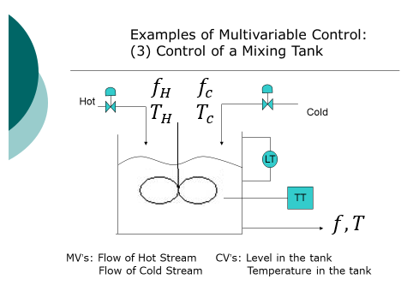

$ρA\frac{dh}{dt}=ρf_{c}+ρf_{H}-ρf$ (1)

$ρAc_{p}\frac{d\left(hT\right)}{dt}=ρAc_{p}\left(h\frac{dT}{dt}+T\frac{dh}{dt}\right)$

$=ρ{c_{p}f_{c}T}_{C}+ρ{c_{p}f_{H}T}_{H}-ρc_{p}Th$ (2)

To simplify (2), let’s rewrite (2) by (2)-(1)*T, and cancelling out $ρ$ and $c_{p}$, we have:

$A\frac{dh}{dt}=f_{c}+f_{H}-f$ (1)’

A $\frac{dT}{dt}=\left[f_{c}\left(T_{c}-T\right)+f_{H}\left(T_{H}-T\right)\right]/h(t)$ (2)’

1. What is steady state temperature, *T* , of the tank?
2. Find the transfer functions for the system including interactions by linearization schemes, if ${MV}_{1}=f_{C}(t), {MV}_{2}=f_{H}(t), {CV}_{1}=h\left(t\right), {CV}_{2}=H\left(t\right)$.
3. Determine the relative gain array.

**Problem #3 (20%)**

Derive a pulse transfer function (z-domain) for the following plants with a zero order hold and a sampling time of 1:

1.  (6 points)
2.  (6 points)
3.  (7 points)

**Problem #4 (20%)**

Consider the following process:

$$\frac{y(s)}{m(s)}=G_{p}\left(s\right)=\frac{2}{3s+1}$$

1. What is the discrete transfer function of this process with a zero-order-hold (T=1 time unit)?
2. What is the equivalent discrete system in the following form: $$y_{k+1}=αy_{k}+βm_{k}$$
3. Can you derive a deadbeat control system for the above system? What is the control law?

**Problem #5 (20%)**

For the stripping section of a distillation column shown below, the objective is to maintain the bottom’s purity at a desired value. The objective is commonly attained by controlling the temperature in one of the trays (the column pressure is assumed constant) by using the steam flow to the reboiler as the manipulated variable. A usual “major” disturbance is the feed flow to the column.

1. Sketch a feedforward/feedback control scheme to compensate for this disturbance; describe it briefly.
2. Briefly describe the dynamic tests that you would perform on the column in order to tune the feedback controller and the feedforward controller. Would you expect the dynamic compensation on the feedforward controller to be a net lead or a net lag?

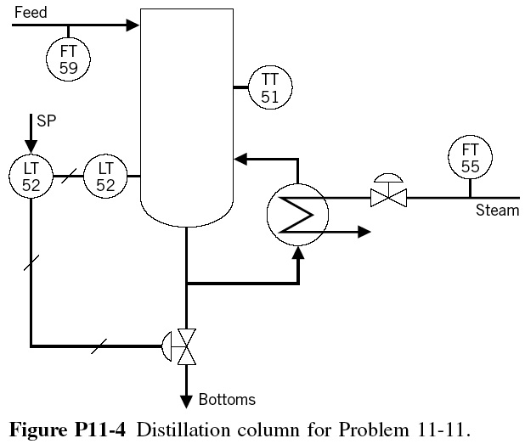

**Problem #6 (20%) Take home**

Consider the above hot-water-cold water system with the following parameters:

A=1m2;

(1) Derive the energy and material balances equations

(2) Write a SIMULINK to simulate the dynamic system with sampling time of 1minute.

(3) Perform dynamic simulation of process control of the multivariable system by assuming a step change of level set point by increasing to 5m with two individual controllers all with Kc=1, τI=1min.

(4) Dervie all transfer functions using step response approximation and draw the plant block functions. Also derive the decoupling system for the plant.

(5) Perform dynamic simulation of process control with decoupling by assuming a step change of level set point by increasing to 5m with two individual controllers all with Kc=1, τI=1min.

(6) Compare the results in (3) and (5).